Eye Diagrams Overview
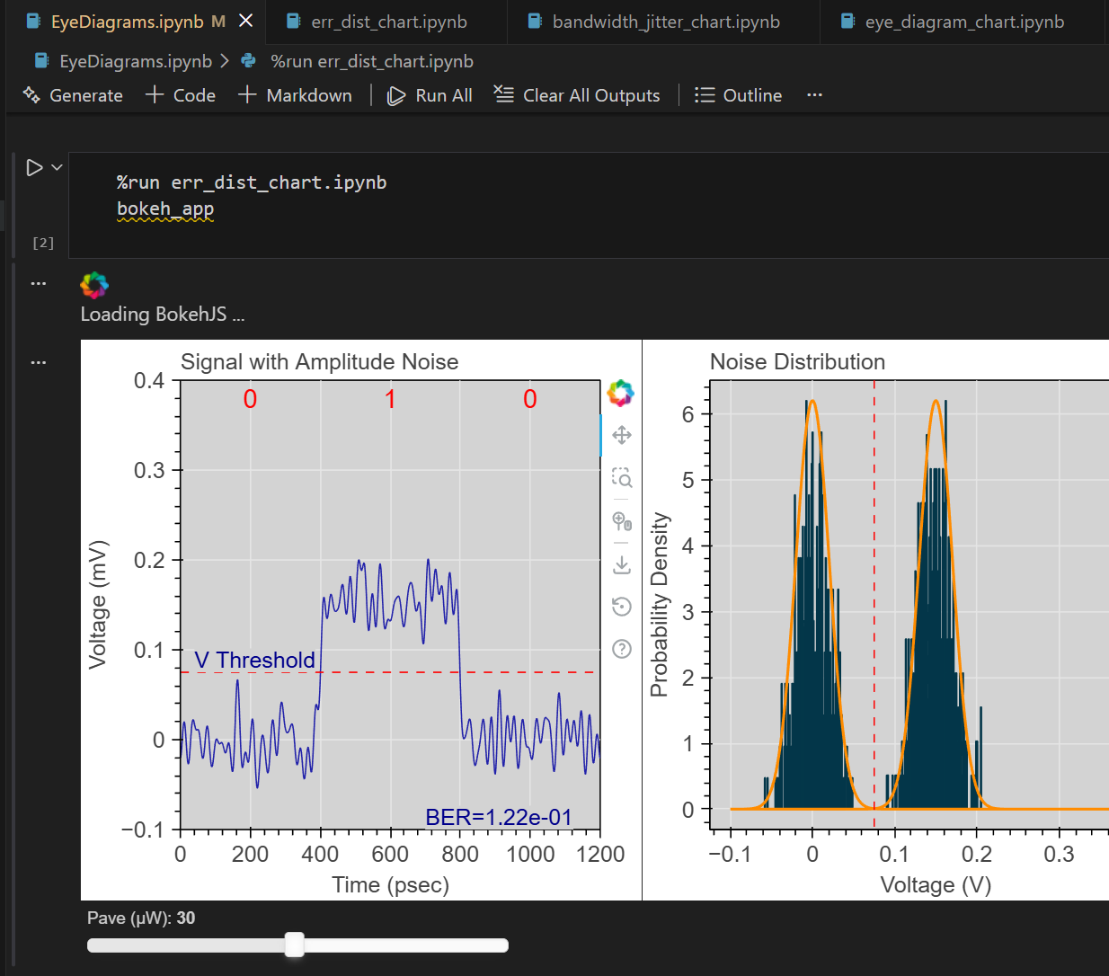The project structure includes a single Jupyer notebook for the end user that calls code in other notebooks as needed to generate interactive plots.

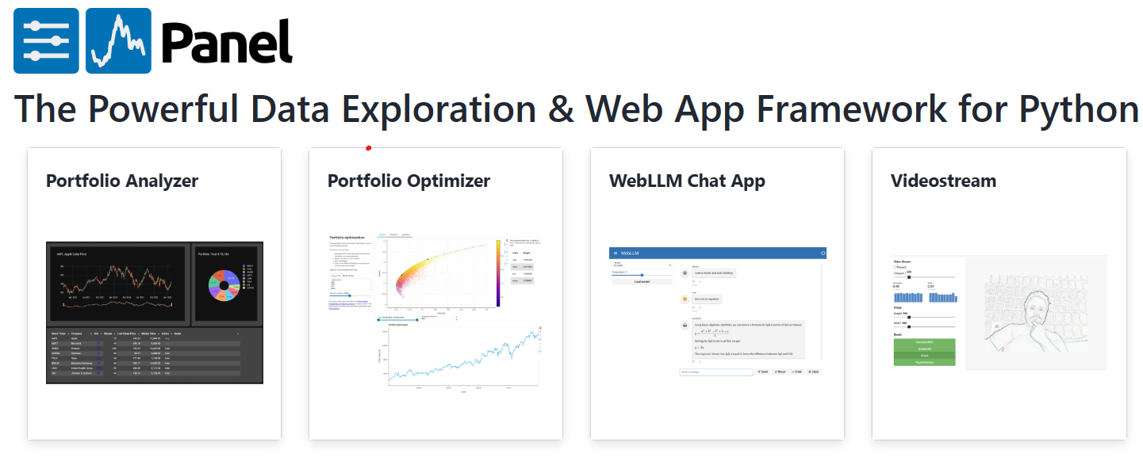
Interactive plots are generated with the Panel dashboarding package. The notebooks are live when running on a computer with a Python environment that includes the Panel package, the NumPy numerical package, and the Bokeh plotting package.

